Zotero is free open source software that helps you manage your references
and formats bibliographies in the documentation style of your choice.
When using Zotero, your references will be available on your PC or Mac and on your Zotero online account.
- Download Zotero at zotero.org. Click the red Download button.
- Download and install the Zotero application for Windows, Mac or Linux.  - Double click the installer set up at the bottom of your browser.  - Grant the Zotero App access to make changes to your computer.  - Follow the steps through the Zotero Setup Wizard to finish installation. | 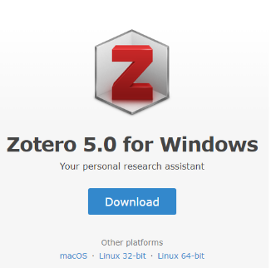  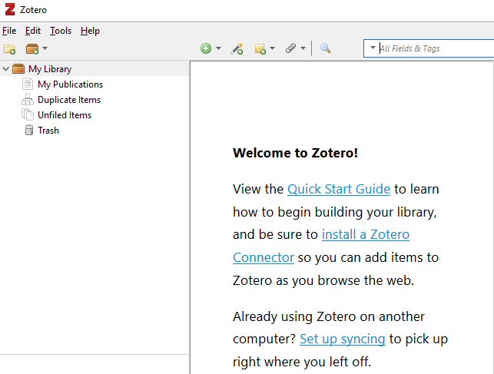
- At zotero.org, download and install the Zotero Connector to your web browser of choice. Click the blue Install Connector button.  - Grant Zotero Connector access to read data on websites you visit.  - Sync Connector to your browser. | 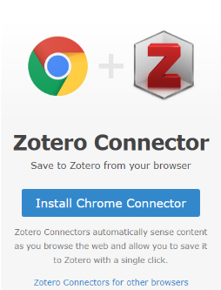
- Register an account at zotero.org by clicking Log In and then Register.
  - Register with your Villanova email address.
  - An email with an activation link will be sent to validate your account.
- Set up Zotero syncing by opening the application and select Preference from the Zotero menu on Mac or the Edit menu on Windows/Linux, and then select the Sync tab.  - Enter the username and password then click Set up Sync.  - Now you can start building your Zotero library. | 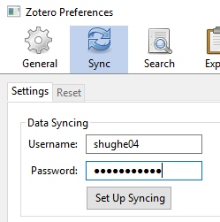
Importing a reference  References can be imported from many sources, including the Falvey catalog, databases and websites. Click the icon in your browser to download the reference. | Journal reference (white paper)  Book reference (blue book)  .
Importing multiple references  The yellow folder icon indicates that there are several different references to articles. Click the icon to display a list. You can then choose to download one or more. | Several references (yellow folder)  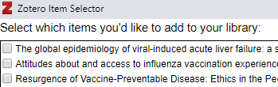
Organizing your references  You can organize your references into folders and subfolders. Create a folder by clicking the add folder icon. | 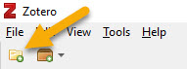
Creating bibliographies  Highlight one or more references. Right click and choose Create Bibliography from Items. Follow the instructions to choose a documentation style. Zotero supports all major styles, as well as styles of individual journals. | 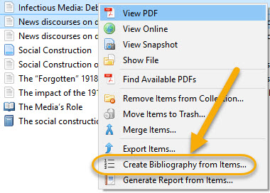
Group libraries  Share references with other Zotero users online. Make sure you sync your library (see step 5).  - To create a shared library, click the Create Groups button near the top left of your Zotero window (Brown fold icon, second from the left).  - To join an existing Zotero library, search for it at zotero.org/groups or be invited by the group’s owner.  - You must log in to the zotero.org website to create or join a group.  Search for existing public groups or create a new group. Groups may be public (searchable, and anyone can join) or private (users can only join if invited). | 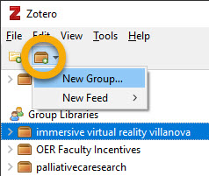  You now have two sections in your Zotero collections pane: My Library and Group Libraries.  Personal and group libraries are entirely separate, and changes made to items in one library do not affect the other. You can drag items back and forth libraries to copy items.
Zotero Word Plugin
Insert citations and bibliographies into Word documents as your write.

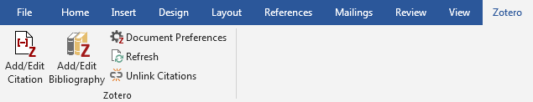

Installation:
- In Zotero, go to your Preferences menu (on Mac, Zotero > Preferences; on PC, Edit > Preferences).
- Click Cite.
- Click Word Processors.
- Click Install Microsoft Word Add-In (or Install LibreOffice Add-in).
- Where is the Zotero menu in Word?
- On a Mac, in MS Word 2016, the Zotero menu will appear in the toolbar.
- On a Mac, in MS Word 2011, the Zotero submenu will appear under the Script menu (looks like a squiggle in the menu bar).
- On a PC, in MS Word, the Zotero menu will appear in the toolbar.

To add an in-text citation or footnote:
- In Word, from the Zotero menu, click Insert Citation (may be an icon). The Zotero dialog box will open.
- In the Zotero dialog box, search for your source.
- Select your source.
- To edit your in-text citation or footnotes, click the source again. You can now add page numbers, prefixes, suffixes (e.g., if you would like to add commentary to a footnote), or suppress the author's name.
- Hit your return key.
- The citation or footnote will be inserted.

To edit an in-text citation or footnote:
- Click once on the in-text citation or footnote you wish to edit.
- In the Zotero menu, click Edit Citation (may be an icon).
- The Zotero dialog box will open.
- Edit the citation as desired and hit your return key.
Storage
Zotero provides 300 MB free online storage. If you store only references, this will probably meet your needs. If you choose to store PDF files of articles, you may need to purchase additional storage from Zotero.
To maximize storage space, choose NOT to automatically download PDFs (General preferences):
For more information about using Zotero, see the online support pages: https://www.zotero.org/support/

